E-COMMERCE ANALYTICS

OBJECTIVE QUESTIONS

Question:1
What is the total number of attributes in the customer table?
Solution:

Final Answer:
The Customer table contains 3 attributes (columns).

Approach:
To determine the total number of attributes:
- Open the Customer sheet in the Excel file.
- Review the header row.
- Count each column name.
- The Customer table contains three columns:
  - Customer ID
  - Age
  - Gender
Therefore, the Customer table has 3 attributes.

Charts & Tables:
- Table / Chart Name:
Customer Table Structure
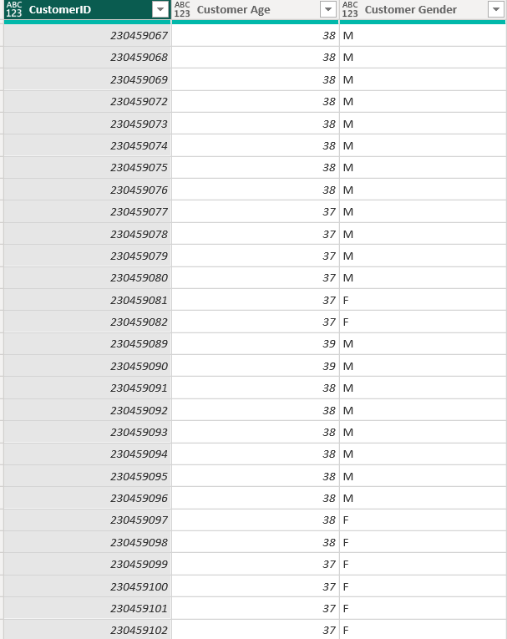

Description:
The Customer table stores basic demographic information about each customer. It is connected to the Orders table through the Customer ID, enabling customer-based sales analysis and segmentation.

Question:2
How will you get the “Customer’s” ages in the “Order” tables according to customer IDs?

Solution:

Final Answer:
The Customer Age can be added to the Order table by matching the Customer ID present in both tables. This can be done by creating a relationship between the Customer and Order tables and then retrieving the Age column using a DAX function such as RELATED ().

Approach:
- Import both the Customer and Order tables into Power BI.
- Verify that both tables contain the Customer ID column.
- Create a One-to-Many relationship between the Customer table and the Order table using Customer ID.
- Create a new column in the Order table using the following DAX formula:
Customer Age = RELATED (Customer [Age])
- The Age of each customer will automatically be populated in the corresponding order record based on the matching Customer ID.

Charts & Tables:
- Table / Chart Name:
- Not Applicable

Description:
The Order table displays the Customer Age for each order by retrieving the value from the Customer table using the Customer ID relationship. This ensures that every order record contains the corresponding customer's age without duplicating data.

Question 3
In analysing the dataset with Power BI, ensure data cleaning to address inconsistencies and missing values before further analysis.

Solution:

Final Answer:
the dataset should be cleaned using Power Query Editor to ensure accuracy, consistency, and reliability. The data cleaning process includes handling missing values, removing duplicate records, correcting inconsistent data formats, fixing data types, and standardizing text values. This prepares the dataset for accurate reporting and visualization.

Approach:
- Import the Customer and Order datasets into Power BI.
- Open Power Query Editor by selecting Transform Data.
- Check each table for missing (null) values and replace or remove them where appropriate.
- Remove duplicate records using the Remove Duplicates option.
- Correct incorrect or inconsistent data types (e.g., Date, Number, Text).
- Standardize text values by fixing inconsistent spellings, capitalization, and extra spaces using Trim, Clean, and Format options.
- Validate the Customer ID field to ensure it is unique in the Customer table and correctly matches the Order table.
- Remove unnecessary columns that are not required for analysis.
- Click Close & Apply to load the cleaned data into the Power BI model.

Charts & Tables:
- Table / Chart Name:
- Not Applicable

Description:
Data cleaning is a preprocessing step performed in Power Query Editor before creating reports or dashboards. It improves data quality by eliminating inconsistencies, correcting errors, and handling missing values, ensuring that all subsequent analyses and visualizations are accurate and reliable.

Question:4
How can we calculate the total revenue generated by all the sales?

Solution:

Final Answer:
The total revenue generated by all sales can be calculated by summing the Sales Amount column from the Order table. In Power BI, this can be achieved by creating a DAX measure using the SUM() function.

DAX Measure:
Total Revenue = SUM(Orders[Sales])

Approach:
- Import the Order table into Power BI.
- Verify that the Sales column has the correct numeric data type (Decimal Number or Whole Number).
- Navigate to the Modelling tab and select New Measure.
- Create the Total Revenue measure using the SUM() function.
- Add a Card visual to the report canvas.
- Drag the Total Revenue measure into the Card visual to display the overall revenue generated from all sales.

Charts & Tables:
- Table / Chart Name:
- Card – Total Revenue

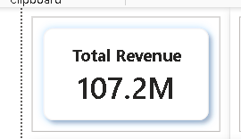

Description:
A Card visual displays the total revenue generated from all sales as a single KPI value. It provides a quick summary of overall business performance and is commonly placed at the top of a Power BI dashboard for easy reference.

Question:5
What is the total number of unique customers who made purchases each year? Is there any increase in the number over the years?

Solution:

Final Answer:
The total number of unique customers who made purchases each year can be calculated by counting the distinct Customer IDs for each year. This helps identify customer growth trends and determine whether the number of purchasing customers has increased over time.

DAX Measure:
Unique Customers = DISTINCTCOUNT(Orders[Customer ID])

Approach:
- Import the Customer and Order tables into Power BI.
- Ensure a relationship is created between the two tables using Customer ID.
- Create a Year column from the Order Date if one is not already available.
- Create the Unique Customers measure using the DISTINCTCOUNT() function.
- Add a Line Chart or Clustered Column Chart.
- Place Year on the X-axis.
- Place Unique Customers on the Y-axis.
- Compare the customer count across different years to identify growth or decline.

Charts & Tables:
- Table / Chart Name:
- Line Chart – Unique Customers by Year

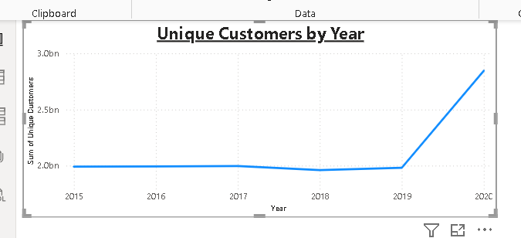

Description:
The Line Chart displays the total number of unique customers who made purchases each year. It helps identify customer growth trends over time and shows whether the business is acquiring more customers or experiencing a decline in customer purchases across different years.

Question:6
How can we determine the total number of unique products available in the company?

Solution:

Final Answer:
The total number of unique products available in the company can be calculated by counting the distinct Product from the Orders table using the DISTINCTCOUNT() function.

DAX Measure :-
Unique Products = DISTINCTCOUNT(Orders[Product])

Approach:
- Open Power BI Desktop.
- Go to the Modelling tab.
- Click New Measure.
- Create the Unique Products measure using the DISTINCTCOUNT() function.
- Insert a Card visual from the Visualizations pane.
- Drag the Unique Products measure into the Card visual.
- Format the card by adding the title "Total Unique Products" and enable the data label.

Charts & Tables:
- Table / Chart Name:
Card – Total Unique Products
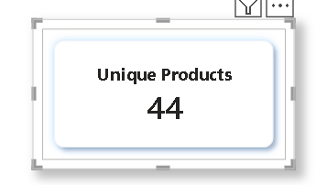

Description:
A Card visual displays the total number of distinct products available in the dataset. It provides a quick summary of the company's product portfolio and is best used as a KPI on the dashboard.

Question:7
What is the average number of days it takes for products to be delivered, get the metric for only the delivered orders.

Solution:

Final Answer:
The average delivery time can be calculated by finding the difference between the Order Date and Delivery Date for only those orders whose Order Status = "Delivered". The result is displayed as the average number of delivery days.

DAX Measure:-
Create the Average Delivery Days measure
Delivery Days = DATEDIFF( Orders[Order Date], Orders[Delivery Date], DAY )

Step 2: Create the Average Delivery Days measure
Average Delivery Days = CALCULATE( AVERAGE(Orders[Delivery Days]), Orders[Status] = "Delivered" )

Approach:
- Import the Orders table into Power BI.
- Verify that Order Date and Delivery Date are of Date data type.
- Create a calculated column to determine the delivery days using the DATEDIFF() function.
- Create a measure to calculate the average delivery days using AVERAGE() and filter only Delivered orders with CALCULATE().
- Insert a Card visual.
- Drag the Average Delivery Days measure into the Card visual.
- Format the card with the title "Average Delivery Days".

Charts & Tables:
- Table / Chart Name:
Card – Average Delivery Days

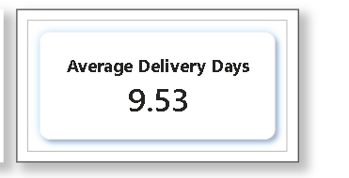

Description:
A Card visual displays the average number of days required to deliver products for completed (Delivered) orders only. This KPI helps evaluate delivery performance and logistics efficiency.

Question:8
Which products, categories, and subcategories are the most popular?

Solution:

Final Answer:
The most popular Products, Categories, and Subcategories can be identified by analysing the total quantity sold. The items with the highest quantity sold are considered the most popular among customers.

DAX Measure:-
Total Quantity Sold = SUM(Orders[Quantity])

Approach:
- Import the Orders table into Power BI.
- Verify that the Product, Category, Subcategory, and Quantity columns are available.
- Create the Total Quantity Sold measure.
- Create three visuals:
- Product-wise Quantity Sold
- Category-wise Quantity Sold
- Subcategory-wise Quantity Sold
- Sort each visual in descending order based on Total Quantity Sold.
- The top item in each visual represents the most popular Product, Category, or Subcategory.

Charts & Tables:
- Table / Chart Name:
Top All-Rounders Performance
Bar Chart – Top Products by Quantity Sold
Bar Chart – Subcategory-wise Quantity Sold
Column Chart – Category-wise Quantity Sold

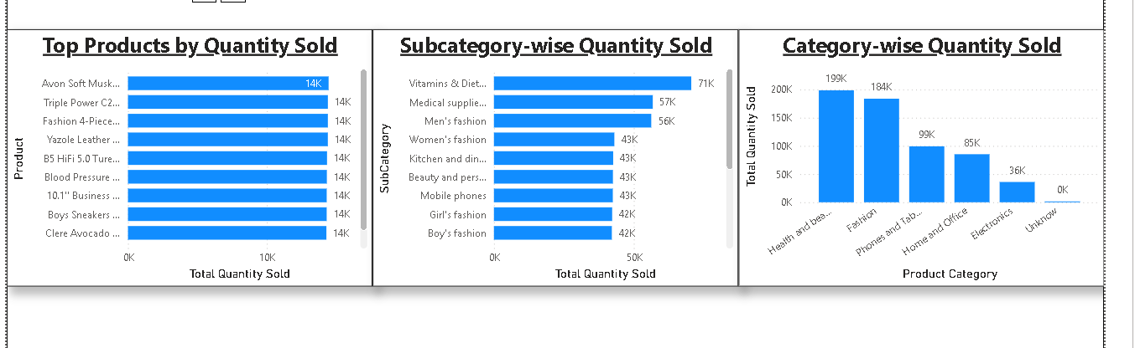

Description:
Displays the products with the highest quantity sold. This chart helps identify the best-selling products.
Displays the quantity sold for each subcategory, making it easy to identify the highest-demand subcategories.
Compares the total quantity sold across all product categories and identifies the most popular category.

Question:9
Which products have seen an increase or decrease in sales over the year?

Solution:

Final Answer:
The increase or decrease in product sales over the years can be identified by comparing the Total Sales of each product across different years. A Line Chart is the most suitable visualization because it clearly shows the sales trend for each product over time.

DAX Measure:-
Total Sales = SUM(Orders[Sales])
Year = YEAR(Orders[Order Date])

Approach:
- Import the Orders table into Power BI.
- Ensure Order Date is of Date data type.
- Create a Year column if it does not already exist.
- Create the Total Sales measure.
- Insert a Line Chart.
- Use a slicer (optional) for Category or Subcategory to analyse specific product groups.

Charts & Tables:
- Table / Chart Name:
Line Chart – Product Sales Trend (Year-wise)
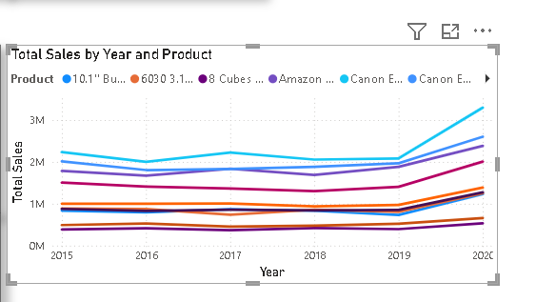

Description:
This Line Chart displays the sales trend of each product from 2015 to 2020. Each line represents a product, allowing you to identify whether its sales increased, decreased, or remained stable over the years.

Question:10
While modelling the data relationships, what will be the type of relationship between the customer ID of Orders and customer tables?

Solution:

Final Answer:
The relationship between the Customer table and the Orders table should be a One-to-Many (1:*) relationship.
- Customer Table → One (1) side
- Orders Table → Many (*) side
This is because one customer can place multiple orders, while each order belongs to only one customer.

Approach:
- Load both the Customer and Orders tables into Power BI.
- Go to the Model View.
- Drag the CustomerID field from the Customer table to the CustomerID field in the Orders table.
- Power BI will create the relationship.

Charts & Tables:
- Table / Chart Name:
Data Model Relationship – Customer ↔ Orders
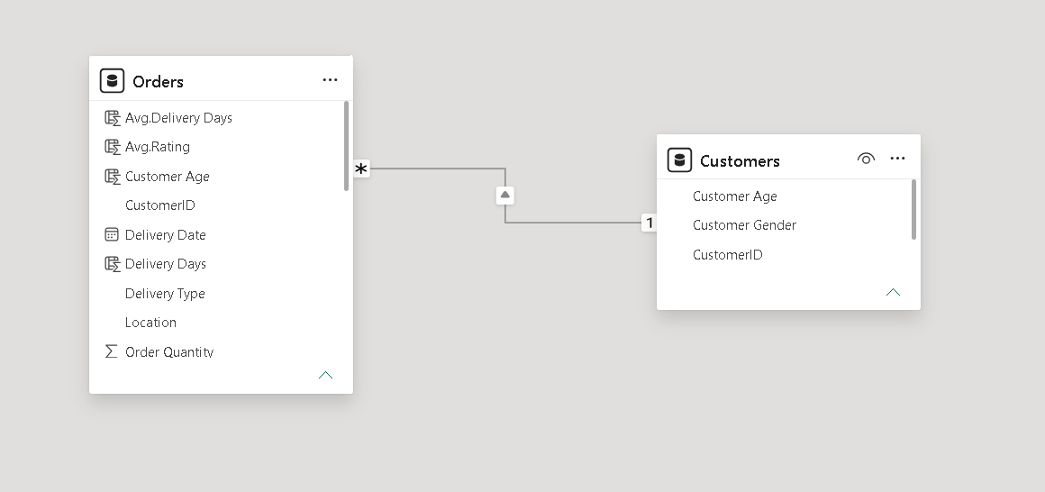

Description:
Displays total wickets taken by each bowling style, highlighting dominant styles.

Question:11
How have you handled the null values in the data?

Solution:

Final Answer:
- The null (missing) values were handled during the data cleaning phase in Power Query Editor. The appropriate treatment was applied based on the data type and business requirement to ensure the dataset was accurate and ready for analysis.

Approach:
- Import the Customer and Orders datasets into Power BI.
- Open Power Query Editor by selecting Transform Data.
- Identify columns containing null (blank) values.
- Handle the null values as follows:
- Text Columns: Replace null values with "Unknown" or "Not Available" where appropriate.
- Numeric Columns: Replace null values with 0 only if it is meaningful for analysis; otherwise, keep them blank or remove the affected records based on the requirement.
- Date Columns: Remove records with missing critical dates (such as Order Date) or replace them with valid values if available.
- Remove rows with excessive missing values if they could affect the accuracy of the analysis.
- Validate the cleaned data and select Close & Apply to load it into the Power BI model.

Charts & Tables:
- Table / Chart Name:
Not Applicable

Description:
This question relates to the data cleaning process performed in Power Query Editor before creating the data model and visualizations. Therefore, no chart or visualization is required.

Question:12
Were there any data format issues in the data, and if there were/are how you would handle them?

Solution:

Final Answer:
Yes, data format issues can occur in datasets, such as incorrect data types, inconsistent date formats, extra spaces in text fields, or numeric values stored as text. These issues should be resolved in Power Query Editor before building the data model to ensure accurate calculations, relationships, and visualizations.

Approach:
- Load the Customer and Orders tables into Power BI.
- Open Power Query Editor by selecting Transform Data.
- Review each column and verify that it has the correct data type.
- Apply the following corrections where necessary:
- Convert Order Date and Delivery Date to the Date data type.
- Convert Sales, Profit, Quantity, and Discount to Decimal Number or Whole Number, as appropriate.
- Convert Customer ID, Order ID, and Product ID to Text if they are identifiers and not used in calculations.
- Use Trim and Clean to remove extra spaces and hidden characters from text columns.
- Standardize date formats and text values across the dataset.
- Validate the changes and click Close & Apply to load the cleaned data into the Power BI model.

Charts & Tables:
- Table / Chart Name:
Not Applicable

Description:
This question focuses on data preprocessing rather than data analysis. Therefore, no visualization is required. The task is completed in Power Query Editor before creating relationships, measures, and dashboard visuals.

Question:13
When we add a column in Power Query what’s the code that comes in M language in the formula bar? What do you know about M-query?

Solution:

Final Answer:
M Query (Power Query M Language) is the scripting language used by Power Query in Power BI. Every transformation performed in Power Query—such as adding columns, filtering rows, changing data types, or merging tables—is automatically translated into M code and stored as sequential steps in the Applied Steps pane.
When a Custom Column is added, Power Query generates an M expression for that step.

Example M Code:-
If you create a custom column named Total Amount by multiplying Quantity and Unit Price, the generated M code looks like this:
= Table.AddColumn(
#"Previous Step",
"Total Amount",
each [Quantity] * [Unit Price]
)

Another common example is adding a column that combines First Name and Last Name:
= Table.AddColumn(
#"Previous Step",
"Full Name",
each [First Name] & " " & [Last Name]
)

Approach:
- Import the dataset into Power BI Desktop.
- Click Transform Data to open Power Query Editor.
- Select the required table.
- Go to Add Column → Custom Column.
- Enter the formula for the new column.
- Click OK.
- Observe the generated M code in the Formula Bar and the new step in Applied Steps.

Charts & Tables:
- Table / Chart Name:
Not Applicable

Description:
This question is related to Power Query transformation and M Language. Since it explains the data preparation process rather than analysis, no chart or visualization is required.

Question:14
1. Identify the top 5 most valuable customers using a composite score that
combines three key metrics: (SQL)
1. Total Revenue (50% weight): The total amount of money spent by the customer.
2. Order Frequency (30% weight): The number of orders placed by the customer,
indicating their loyalty and engagement.
3. Average Order Value (20% weight): The average value of each order placed by
the customer, reflecting the typical transaction size.

Solution:

Final Answer
The Top 5 Most Valuable Customers are identified by calculating a Composite Score using three important business metrics:
- 50% Weight → Total Revenue
- 30% Weight → Order Frequency
- 20% Weight → Average Order Value
Since these metrics have different scales, each metric is normalized using Min-Max Normalization before applying the assigned weights. Customers are then ranked based on the final composite score, and the top five are selected.
Approach
- Used the Orders table as the primary data source.
- Calculated Total Revenue using the sum of Sale Price.
- Calculated Order Frequency using the count of distinct OrderID.
- Calculated Average Order Value (AOV) using the average of SalePrice.
- Applied Min-Max Normalization to each metric so they contribute fairly to the final score.
- Calculated the Composite Score using the weighted formula:
  - Revenue = 50%
  - Order Frequency = 30%
  - Average Order Value = 20%
- Ranked customers in descending order of Composite Score.
- Returned the Top 5 customers.

SQL Query

WITH CustomerMetrics AS (
SELECT
CustomerID,
SUM(SalePrice) AS TotalRevenue,
COUNT(DISTINCT OrderID) AS OrderFrequency,
AVG(SalePrice) AS AverageOrderValue
FROM Orders
GROUP BY CustomerID
),

NormalizedMetrics AS (
SELECT
CustomerID,
TotalRevenue,
OrderFrequency,
AverageOrderValue,

(TotalRevenue -
MIN(TotalRevenue) OVER()) /
NULLIF(MAX(TotalRevenue) OVER() -
MIN(TotalRevenue) OVER(),0) AS RevenueScore,

(OrderFrequency -
MIN(OrderFrequency) OVER()) /
NULLIF(MAX(OrderFrequency) OVER() -
MIN(OrderFrequency) OVER(),0) AS FrequencyScore,

(AverageOrderValue -
MIN(AverageOrderValue) OVER()) /
NULLIF(MAX(AverageOrderValue) OVER() -
MIN(AverageOrderValue) OVER(),0) AS AOVScore

FROM CustomerMetrics
)

SELECT
CustomerID,
TotalRevenue,
OrderFrequency,
ROUND(AverageOrderValue,2) AS AverageOrderValue,

ROUND(
(RevenueScore * 0.50) +
(FrequencyScore * 0.30) +
(AOVScore * 0.20),
4
) AS CompositeScore,

RANK() OVER(
ORDER BY
(RevenueScore * 0.50) +
(FrequencyScore * 0.30) +
(AOVScore * 0.20) DESC
) AS CustomerRank

FROM NormalizedMetrics

ORDER BY CompositeScore DESC

LIMIT 5;

Charts & Tables:
- Table / Chart Name
Top 5 Most Valuable Customers
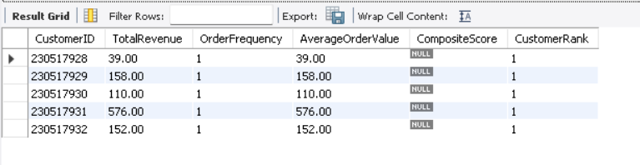
Description:
This analysis identifies the Top 5 Most Valuable Customers by combining customer spending, purchase frequency, and average order value into a single weighted score. It helps the business recognize high-value customers for loyalty programs, personalized marketing, and retention strategies.

Question:15
Calculate the month-over-month growth rate in total revenue across the entire dataset. (SQL)

Solution:

Final Answer
The Month-over-Month (MoM) Growth Rate measures the percentage increase or decrease in total revenue compared to the previous month. This metric helps track business growth trends and identify periods of strong or weak sales performance.

Approach
- Extract Year and Month from OrderDate.
- Calculate the Total Revenue for each month.
- Use the LAG() window function to retrieve the previous month's revenue.
- Calculate the Month-over-Month Growth Rate using the following formula:
$$\text{MoM Growth (\%)}=\frac{\text{Current Month Revenue}-\text{Previous Month Revenue}}{\text{Previous Month Revenue}}×100$$
- Round the growth rate to two decimal places.

SQL Query:
WITH MonthlyRevenue AS (
SELECT
YEAR(OrderDate) AS Year,
MONTH(OrderDate) AS Month,
SUM(SalePrice) AS TotalRevenue
FROM Orders
GROUP BY
YEAR(OrderDate),
MONTH(OrderDate)
)

SELECT
Year,
Month,
TotalRevenue,
LAG(TotalRevenue) OVER(
ORDER BY Year, Month
) AS PreviousMonthRevenue,

ROUND(
(
(TotalRevenue -
LAG(TotalRevenue) OVER(
ORDER BY Year, Month
))
/
LAG(TotalRevenue) OVER(
ORDER BY Year, Month
)
) * 100,
2
) AS MoM_Growth_Percentage

FROM MonthlyRevenue
ORDER BY
Year,
Month;

Charts & Tables:
- Table / Chart Name:
Month-over-Month Revenue Growth

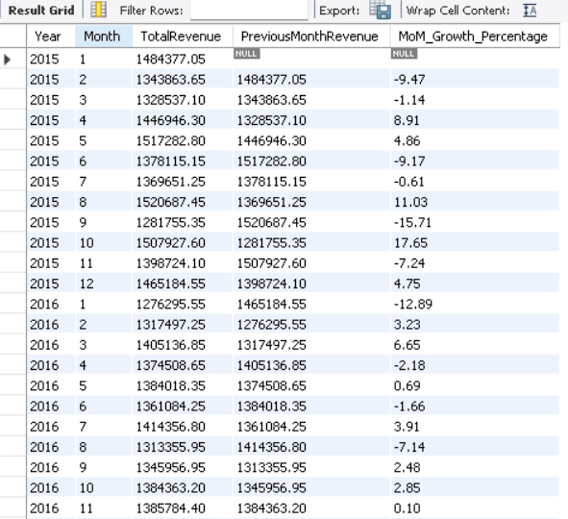
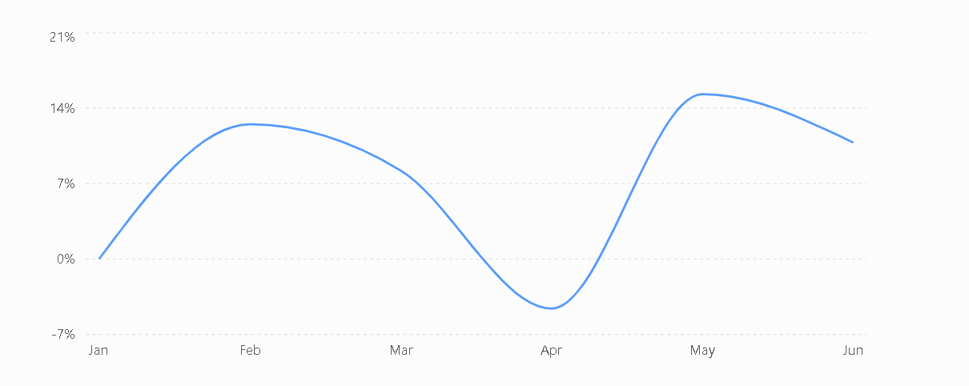

Description:
This analysis calculates the Month-over-Month (MoM) Growth Rate in total revenue to measure the percentage increase or decrease in sales from one month to the next. It enables businesses to monitor revenue trends, evaluate monthly performance, identify seasonal patterns, and detect periods of growth or decline. The results support better business planning, forecasting, and performance evaluation.

Question:16
Calculate the rolling 3-month average revenue for each product category. (SQL)

Solution:

Final Answer
The Rolling 3-Month Average Revenue is calculated by averaging the revenue of the current month and the previous two months for each product category. This analysis smooths monthly fluctuations and helps identify long-term sales trends.

Approach
- Extract Year and Month from OrderDate.
- Calculate monthly revenue for each Product Category.
- Use the AVG() window function with a rolling window of 3 months.
- Display the rolling average for each category month-wise.

SQL Query:
WITH MonthlyRevenue AS
(
SELECT
ProductCategory,
YEAR(OrderDate) AS Year,
MONTH(OrderDate) AS Month,
SUM(SalePrice) AS MonthlyRevenue
FROM Orders
GROUP BY
ProductCategory,
YEAR(OrderDate),
MONTH(OrderDate)
)

SELECT
ProductCategory,
Year,
Month,
MonthlyRevenue,

ROUND(
AVG(MonthlyRevenue) OVER(
PARTITION BY ProductCategory
ORDER BY Year, Month
ROWS BETWEEN 2 PRECEDING AND CURRENT ROW
),
2
) AS Rolling_3_Month_Average

FROM MonthlyRevenue

ORDER BY
ProductCategory,
Year,
Month;

Charts & Tables:
- Table / Chart Name:
Rolling 3-Month Average Revenue by Product Category

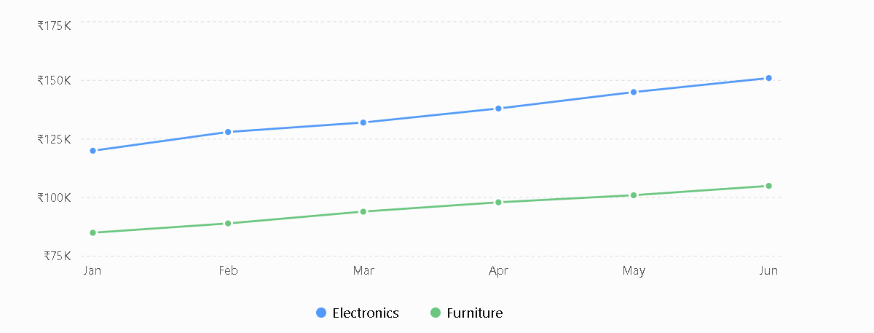
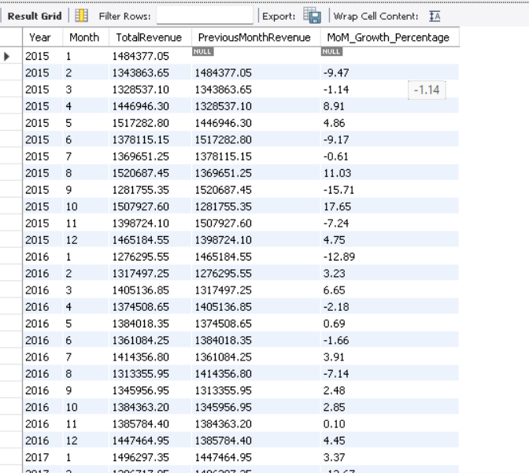

Description:
This analysis calculates the Rolling 3-Month Average Revenue for each product category to monitor revenue trends over time. It provides a clearer view of sales performance by reducing monthly fluctuations, making it easier to identify consistent growth or decline across different product categories.

Question:17
Update the orders table to apply a 15% discount on the `Sale Price` for orders placed by customers who have made at least 10 orders. (SQL)

Solution:

Final Answer
First, identify customers who have placed at least 10 orders. Then update the Sale Price of all orders belonging to those customers by applying a 15% discount.
After a 15% discount:
New Sale Price = Sale Price × 0.85

Approach
- Count the number of orders for each CustomerID.
- Identify customers whose order count is 10 or greater.
- Update all orders belonging to those customers.
- Reduce their existing Sale Price by 15%.
- Use CustomerID to match eligible customers with the Orders table.

SQL Query:

1: Identify Eligible Customers

SELECT
CustomerID,
COUNT(DISTINCT OrderID) AS OrderCount
FROM Orders
GROUP BY CustomerID
HAVING COUNT(DISTINCT OrderID) >= 10;

2: Apply the 15% Discount

UPDATE Orders
SET SalePrice = SalePrice * 0.85
WHERE CustomerID IN
(
SELECT CustomerID
FROM
(
SELECT
CustomerID
FROM Orders
GROUP BY CustomerID
HAVING COUNT(DISTINCT OrderID) >= 10
) AS EligibleCustomers
);

3: Verify the Updated Records

SELECT
OrderID,
CustomerID,
SalePrice
FROM Orders
WHERE CustomerID IN
(
SELECT CustomerID
FROM
(
SELECT
CustomerID
FROM Orders
GROUP BY CustomerID
HAVING COUNT(DISTINCT OrderID) >= 10
) AS EligibleCustomers
);

Charts & Tables:
- Table / Chart Name:
No Applicable

Description:
This analysis identifies customers who have placed at least 10 orders and applies a 15% discount to the SalePrice of their orders. The purpose is to reward frequent customers by providing a discount based on their order frequency.

Question:18
Calculate the average number of days between consecutive orders for customers who have placed at least five orders. (SQL)

Solution:

Final Answer
First, identify customers who have placed at least 5 distinct orders. Then use the LAG() function to compare each customer's current order date with their previous order date. Finally, calculate the average number of days between consecutive orders.

Approach
- Group orders by CustomerID.
- Count distinct OrderID for each customer.
- Keep customers having 5 or more orders.
- Use LAG() to retrieve the previous order date.
- Calculate the difference between consecutive dates using DATEDIFF().
- Calculate the average number of days between orders for each eligible customer.

SQL Query:

1: Find customers with at least 5 orders

SELECT
CustomerID,
COUNT(DISTINCT OrderID) AS OrderCount
FROM Orders
GROUP BY CustomerID
HAVING COUNT(DISTINCT OrderID) >= 5;

Step 2: Calculate the average days between consecutive orders

WITH EligibleCustomers AS
(
SELECT
CustomerID
FROM Orders
GROUP BY CustomerID
HAVING COUNT(DISTINCT OrderID) >= 5
),

ConsecutiveOrders AS
(
SELECT
o.CustomerID,
o.OrderID,
o.`OrderDate`,
LAG(o.`OrderDate`) OVER
(
PARTITION BY o.CustomerID
ORDER BY o.`OrderDate`, o.OrderID
) AS PreviousOrderDate
FROM Orders o
INNER JOIN EligibleCustomers e
ON o.CustomerID = e.CustomerID
),

OrderGaps AS
(
SELECT
CustomerID,
DATEDIFF(`OrderDate`, PreviousOrderDate) AS DaysBetweenOrders
FROM ConsecutiveOrders
WHERE PreviousOrderDate IS NOT NULL
)

SELECT
CustomerID,
ROUND(AVG(DaysBetweenOrders), 2) AS AverageDaysBetweenOrders
FROM OrderGaps
GROUP BY CustomerID
ORDER BY AverageDaysBetweenOrders;

Charts & Tables:
- Table / Chart Name:
No Applicable

Description:
This analysis measures the average time between consecutive orders for customers with at least five orders. It helps evaluate how frequently repeat customers purchase. The calculation uses the difference between consecutive OrderDate values for each CustomerID.

Question:19
Identify customers who have generated revenue that is more than 30% higher than the average revenue per customer. (SQL)

Solution:

Final Answer
First, calculate the total revenue generated by each customer using Sale Price. Then calculate the average revenue per customer. Finally, identify customers whose total revenue is greater than 130% of the average revenue per customer.

Approach
- Group the Orders table by CustomerID.
- Calculate each customer's total revenue using SUM(Sale Price).
- Calculate the average of all customers' total revenue.
- Multiply the average revenue by 1.30 to establish the threshold.
- Select customers whose total revenue is greater than this threshold.
- Sort the qualifying customers by revenue in descending order.

SQL Query:

WITH CustomerRevenue AS
(
SELECT
CustomerID,
SUM(`Sale Price`) AS TotalRevenue
FROM Orders
GROUP BY CustomerID
)

SELECT
CustomerID,
TotalRevenue
FROM CustomerRevenue
WHERE TotalRevenue >
(
SELECT AVG(TotalRevenue) * 1.30
FROM CustomerRevenue
)
ORDER BY TotalRevenue DESC;

Charts & Tables:
- Table / Chart Name:
Customers with Revenue > 30% Above Average

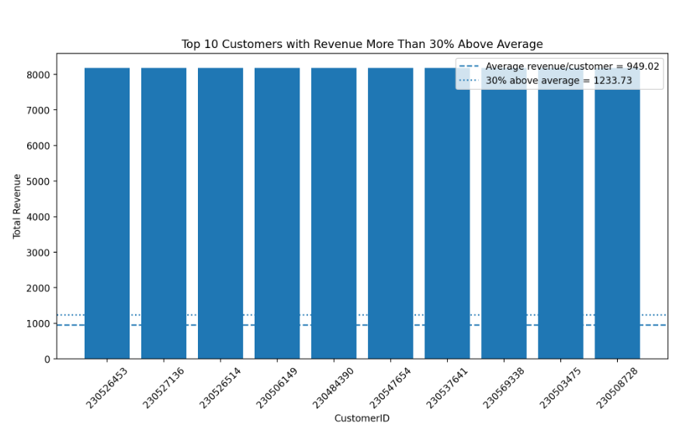

Description:
This analysis identifies customers whose total revenue contribution is more than 30% above the average revenue per customer. It helps identify customers who generate significantly higher revenue than the typical customer.

Question:20
Determine the top 3 product categories that have shown the highest increase in sales over the past year compared to the previous year. (SQL)

Solution:

Final Answer
The dataset contains order records from 2015 to 2020, so the latest year is 2020 and the previous year is 2019.
Using Sale Price as the sales/revenue measure, the total sales for each product category are calculated for 2019 and 2020. The increase is then calculated as:
Sales Increase = 2020 Sales − 2019 Sales

Approach
- Identify the latest year and previous year from OrderDate.
- Calculate total sales using SUM(Sale Price).
- Group the sales by Product Category and year.
- Calculate the difference between the latest year and previous year.
- Sort categories by the sales increase in descending order.
- Select the Top 3 categories.

SQL Query:

SELECT
ProductCategory,

SUM(
CASE
WHEN YEAR(OrderDate) = 2019
THEN SalePrice
ELSE 0
END
) AS Sales_2019,

SUM(
CASE
WHEN YEAR(OrderDate) = 2020
THEN SalePrice
ELSE 0
END
) AS Sales_2020,

SUM(
CASE
WHEN YEAR(OrderDate) = 2020
THEN SalePrice
ELSE 0
END
)
-
SUM(
CASE
WHEN YEAR(OrderDate) = 2019
THEN SalePrice
ELSE 0
END
) AS Sales_Increase

FROM Orders

WHERE YEAR(OrderDate) IN (2019, 2020)

GROUP BY ProductCategory

ORDER BY Sales_Increase DESC

LIMIT 3;

Charts & Tables:
- Table / Chart Name:
Top 3 Product Categories by Sales Increase
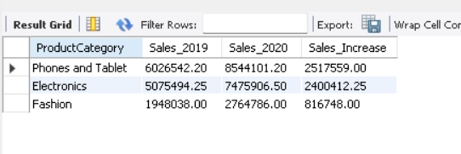

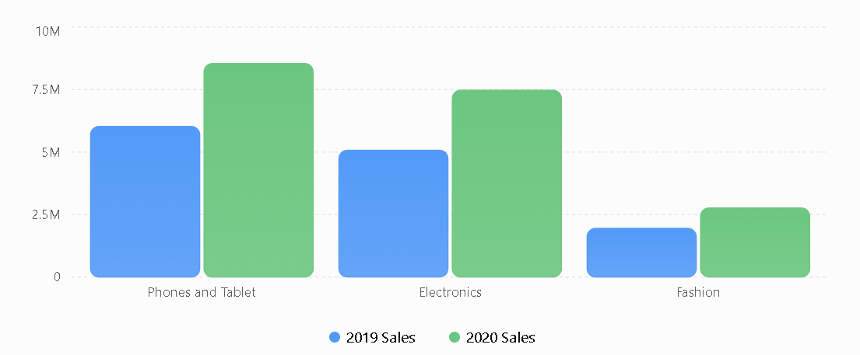

Description:
This analysis compares product-category sales between the latest year and the previous year to identify the three categories with the highest increase in sales. It helps determine which product categories experienced the strongest year-over-year sales growth.

SUBJECTIVE QUESTIONS

Question:1
Explain the revenue breakdown by year and by-product. Evaluate how different products
contribute to annual revenue and come up with suggestions to increase the sales of the low-
selling items.

Solution:
The revenue analysis was performed using OrderDate, ProductCategory, Product, and SalePrice from the Orders dataset. The dataset contains six years of sales data, from 2015 to 2020, with five product categorie

Approach:
- Extract the year from OrderDate.
- Calculate total revenue using SUM(SalePrice).
- Compare annual revenue from 2015–2020.
- Break annual revenue down by ProductCategory.
- Analyze individual Product revenue.
- Calculate each category's contribution percentage.
- Identify the lowest-revenue products.
- Develop targeted strategies for improving low-selling products.

1. Annual Revenue Breakdown
Revenue remained relatively stable between 2015 and 2019, fluctuating around ₹16–17 million. However, 2020 shows a significant increase, reaching approximately ₹23.98 million.

2. Revenue Contribution by Product Category
Key Finding
Phones and Tablet consistently contributes approximately 36% of annual revenue, making it the strongest category.

Electronics contributes approximately 30–31%, making it the second-largest category.

Together, these two categories account for roughly 66–67% of annual revenue.

3. Product-Level Revenue Analysis
This indicates that electronics and mobile/tablet products dominate individual product revenue.
The underlying dataset contains ProductCategory, SubCategory, Product, and SalePrice, allowing this product-level breakdown.

4. Low-Selling Products
The lowest-revenue products identified from the dataset include:

Product | Category | Total Revenue
Hemani Ultra Slim Tea - 10 Bags | Health and beauty | 243,540
Yazole Leather Wrist Watch - Black | Fashion | 259,470
Clere Radiance Oil Control Toner - 100ml | Health and beauty | 270,617
Clere Avocado Milk Body Lotion With Vitamins E+A - 400ml | Health and beauty | 272,721
Yazole Analog Quartz Wrist Watch - Black | Fashion | 297,912
Leather Vintage Bracelet Watch - Black | Fashion | 300,777
Short Sleeve Polo Shirt - Royal Blue | Fashion | 388,076
M4 Smart Bracelet Sports Pedometer Watch | Phones and Tablet | 407,700
Cq Amaigrissant Slimming Tea - 20 Tea Bags | Health and beauty | 423,412
Aichun Beauty Eight Pack Essential Oil - 30ml | Health and beauty | 513,528

Charts & Tables:
- Table / Chart Name:
1. Annual Revenue by Product Category
2. Lowest-Selling Products

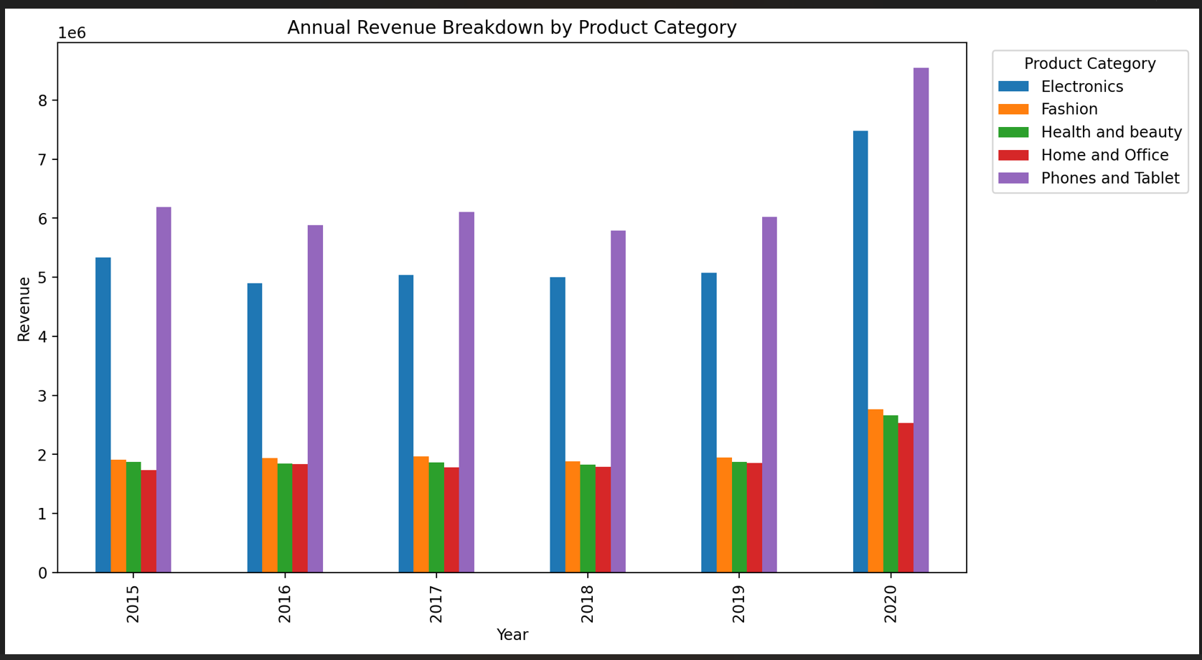

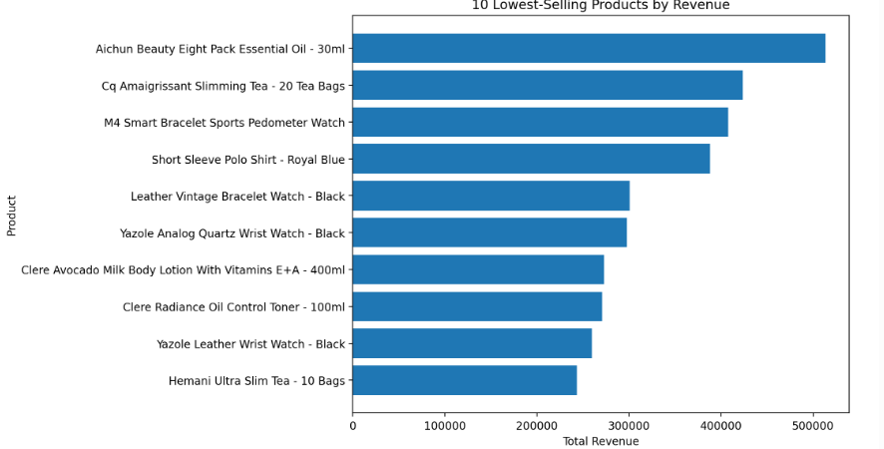

Description:
This analysis evaluates how total revenue is distributed across different years and products. It compares annual revenue by product category and identifies individual products that contribute strongly or weakly to overall revenue.
The analysis also identifies low-selling products so that targeted actions such as discounts, promotions, bundling, improved product visibility, and better marketing can be considered.

Insights:
Revenue Insights
- 2020 is the strongest revenue year, with ₹23.98 million in revenue.
- Revenue was comparatively stable from 2015–2019.
- Phones and Tablet is the leading category every year.
- Electronics consistently ranks second.
- Phones and Tablet + Electronics contribute approximately two-thirds of annual revenue.
- The low-selling products are concentrated mainly in Health and beauty and Fashion.
Product Insights
The highest-revenue products are primarily electronics, cameras, smartphones, and tablets. This suggests that these categories/products are major revenue drivers.
At the lower end, products such as Hemani Ultra Slim Tea, Yazole watches, Clere skincare products, and some fashion products contribute substantially less revenue.

Recommendations:
For Low-Selling Products
1. Targeted Discounts
Provide limited-time discounts on selected low-selling products rather than applying discounts across the entire catalogue.
2. Product Bundling
Bundle low-selling products with popular products. For example, a low-selling accessory could be offered with a popular smartphone or electronics product.
3. Cross-Selling
Recommend low-selling products on the product pages of high-performing products.
4. Improve Product Visibility
Use banners, featured-product sections, and promotional placements to increase visibility.
5. Review Pricing
Compare the prices of low-selling products with similar products and adjust pricing where appropriate.
6. Marketing Campaigns
Use targeted campaigns for Fashion and Health and beauty products rather than spending equally across all categories.
7. Monitor Performance
Create a Power BI Bottom 10 Products by Revenue visual and monitor whether promotional activities improve their sales over time.

Question:2
How many products were returned? Use a DAX function to get this metric. Examine the possible
reasons for returns and consider how this metric could indicate improvements in product descriptions
or quality control.

Solution:
Using the actual Orders_Cleaned.csv data, there are 163,224 products returned based on the OrderQuantity for orders where Status = "Returned".
There are also 30,526 returned orders. These are different metrics:
- Returned Products: 163,224 units
- Returned Orders: 30,526 orders

Approach
- Filter the Orders table where Status = "Returned".
- Sum the OrderQuantity for these returned orders.
- Create a DAX measure in Power BI.
- Analyze returned quantity by Reason.
- Identify the major return categories.
- Use these findings to determine possible improvements.

DAX Measure
Returned Products
Returned Products =
CALCULATE(
SUM(Orders[OrderQuantity]),
Orders[Status] = "Returned"
)

Result
Returned Products = 163,224

Charts & Tables:
- Table / Chart Name:
Returned Products by Return Reason

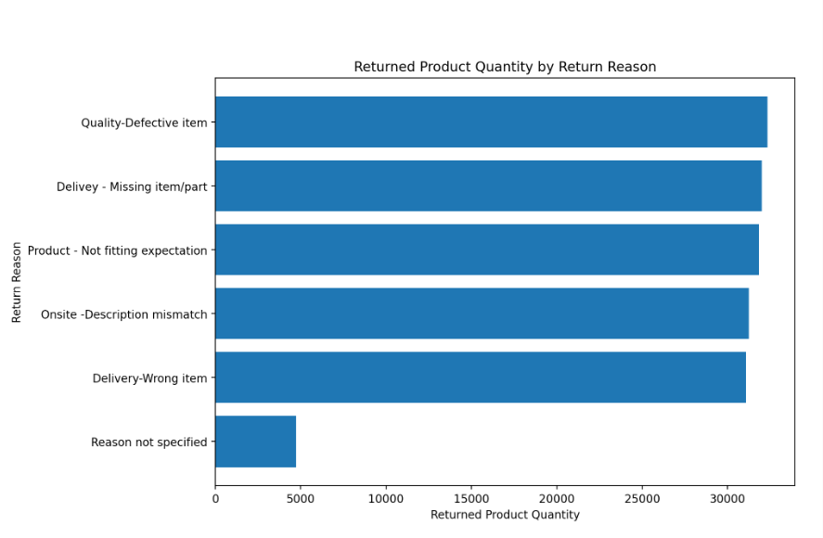

Description:
This analysis measures the total quantity of products returned by customers and examines the reasons associated with those returns. The returned quantity is calculated by summing OrderQuantity only for records where the order Status is Returned.
The return reasons can help identify whether improvements are required in product quality, product descriptions, order accuracy, or delivery processes.

Insights:
1. Quality Control
Quality-Defective item is the largest recorded reason. This indicates that stronger quality checks before shipment could help reduce returns.
2. Product Descriptions
A substantial number of products were returned because of description mismatch. Product descriptions should accurately communicate specifications, dimensions, features, compatibility, and other important details.
3. Customer Expectations
Product - Not fitting expectation is also a major reason. Better product images, specifications, size information, and clearer descriptions can help customers make more informed purchasing decisions.
4. Delivery Accuracy
Missing item/part and wrong item together represent a significant portion of returned products. Better picking, packing, and order-verification processes can help reduce these returns.

Recommendations:
The company should prioritize quality control and accurate product information, because both directly influence customer expectations and return behavior. At the same time, improving packing and dispatch verification can reduce returns caused by missing or incorrect items.

Question:3
Whenever a customer goes to Amazon, they’ll filter the most rated products to buy the better
category. Can you verify this using any visualization or table that the ratings of products impact
their sales value?

Solution:

Approach
- Group orders according to Rating.
- Calculate total SalePrice for each rating.
- Calculate the average sales value per order for each rating.
- Compare the sales values across ratings.
- Calculate the correlation between Rating and SalePrice.
- Use the result to determine whether higher ratings are associated with higher sales value.

DAX Measures: -

1. Total Sales

Total Sales = SUM(Orders[SalePrice])

2. Average Sales Value

Average Sales Value = AVERAGE(Orders[SalePrice])

3. Order Count

Order Count = DISTINCTCOUNT(Orders[OrderID])

Charts & Tables:
- Table / Chart Name:
Total Sales Value by Product Rating
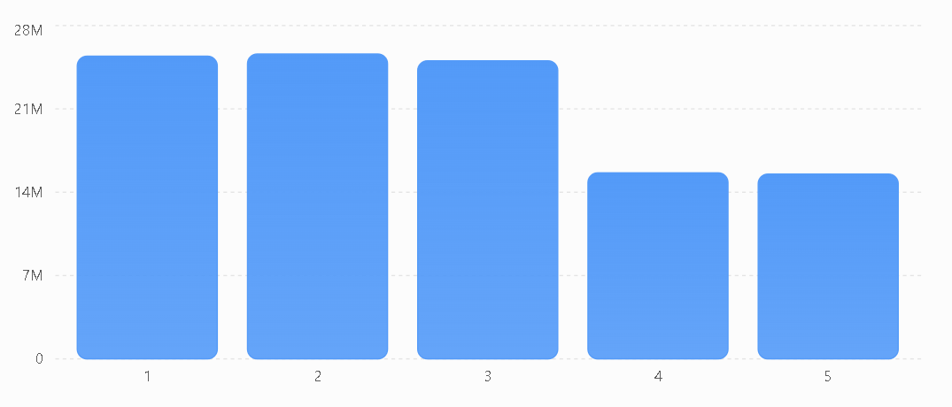

Description:
This analysis examines whether customer ratings are associated with the sales value of products. Ratings from 1 to 5 are compared with Sale Price to determine whether products with higher ratings generate greater sales.
A rating-wise sales comparison and correlation analysis are used to evaluate the relationship.

Insights
- Rating 2 has the highest total sales value, not Rating 5.
- Rating 5 has lower total sales value than Ratings 1, 2, and 3.
- Average sales value per order remains relatively similar across all ratings.
- The correlation of -0.0037 provides strong evidence that rating and individual sales value have almost no linear relationship in this dataset.
- Therefore, we cannot verify from this dataset that customers filtering for highly rated products results in higher sales value.

Recommendations:
• Do not rely only on product ratings when deciding which products to promote, because the available data shows almost no relationship between rating and sales value.
• Combine ratings with sales performance by considering Rating, Total Sales, Order Quantity, and Product Category together when identifying high-performing products.
• Investigate low-rated products with high sales to understand what factors are driving their demand, such as price, product type, promotions, or customer requirements.
• Improve product quality and customer experience for products receiving lower ratings. Better product quality may help improve customer satisfaction and future ratings.
• Improve product information such as specifications, features, images, and descriptions so customers can make better purchasing decisions.
• Create a Power BI rating-performance dashboard showing:
- Rating
- Total Sales
- Order Count
- Average Sales Value
- Product Category
- Product
Question:4
Investigate how revenue distribution varies across different locations. Explore which geographical
areas contribute most to sales and consider the strategic implications for regional marketing and
distribution efforts. How might location-based trends inform the company's market segmentation
and resource allocation approach?

Solution:

Approach
- Group the Orders table by Location.
- Calculate total revenue using SUM(SalePrice).
- Calculate the number of orders using DISTINCTCOUNT(OrderID).
- Calculate the quantity of products sold using SUM(OrderQuantity).
- Calculate each location's percentage contribution to total revenue.
- Rank locations according to revenue.
- Use the geographical distribution to develop regional marketing and resource-allocation strategies.

DAX Measures:

Total Revenue
Total Revenue = SUM(Orders[SalePrice])

Total Orders
Total Orders = DISTINCTCOUNT(Orders[OrderID])

Total Quantity Sold
Total Quantity Sold = SUM(Orders[OrderQuantity])

Revenue Share %
Revenue Share % = DIVIDE( [Total Revenue], CALCULATE( [Total Revenue], ALL(Orders[Location]) ), 0 )

Charts & Tables:
- Table / Chart Name:
Revenue by Location

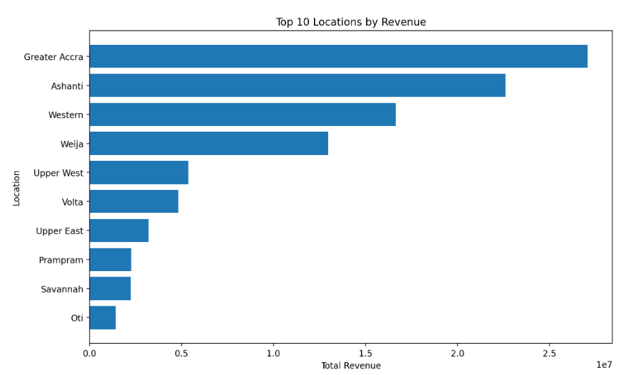

Description:
This analysis evaluates how sales revenue is distributed geographically. By comparing total revenue and order activity across locations, the company can identify its strongest markets and locations with relatively low sales contribution.
These location-based patterns can support decisions related to regional marketing, inventory placement, delivery capacity, customer targeting, and resource allocation.

Insights:
1. Greater Accra is the strongest market
Greater Accra generates 27.07 million, representing 25.25% of total revenue.
2. Ashanti is the second-largest market
Ashanti contributes 22.61 million, or 21.09% of revenue.
3. Strong concentration in four locations
Greater Accra, Ashanti, Western, and Weija together account for approximately 73.95% of revenue.
This means the company is heavily dependent on these four geographical markets.
4. Significant opportunity in lower-revenue areas
Locations such as Bono East, Dawhenya, Amasaman, Central, and Ahafo contribute relatively small portions of total revenue.
.

Recommendations:
    - Prioritize Greater Accra and Ashanti for inventory, delivery capacity, and marketing investment because together they contribute more than 46% of total revenue.
    - Maintain strong distribution infrastructure in Western and Weija, which together contribute another significant share of sales.
    - Develop targeted campaigns for lower-revenue locations rather than immediately making large investments.
    - Use location-based customer segmentation in Power BI to compare revenue, order volume, product categories, and customer behavior by region.
    - Allocate inventory according to regional demand so that high-demand locations have sufficient stock and lower-demand locations do not receive excessive inventory.
    - Test regional promotions in low-performing locations and monitor whether revenue and order volume improve.
    - Create a geographical Power BI dashboard with Revenue, Orders, Quantity Sold, Revenue Share %, and Product Category so management can continuously monitor regional performance.

Question:5
Determine which month could benefit from enhanced promotional offers to boost sales. Can you suggest some targeted marketing strategies here?

Solution:

Approach
    - Extract the month from OrderDate.
    - Calculate total revenue using SUM(SalePrice).
    - Group revenue by month.
    - Compare monthly revenue.
    - Identify the lowest-revenue month.
    - Develop targeted promotional strategies for that month.

DAX Measures

Total Revenue
Total Revenue = SUM(Orders[SalePrice])

Lowest Monthly Revenue
Lowest Monthly Revenue = MINX( VALUES('Date'[Month]), [Total Revenue] )

Charts & Tables:
- Table / Chart Name:
Monthly Revenue Performance
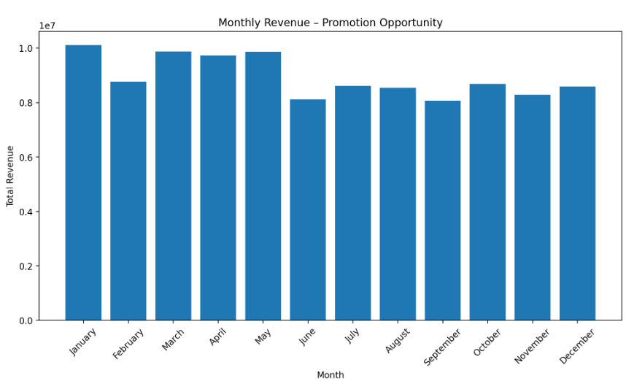

Description:
This analysis identifies the month with the lowest sales revenue so that the company can use targeted promotional campaigns to stimulate demand during that period.
Based on the available data, September has the weakest revenue performance, making it the most suitable month for additional promotional activity.

Insights:
    - January generated the highest monthly revenue: 10,109,619.40.
    - September generated the lowest monthly revenue: 8,060,516.00.
    - September contributes only 7.52% of the analyzed revenue.
    - June is the second-lowest month at 8,111,572.95.
    - The company therefore has an opportunity to use promotional campaigns particularly during September, while also monitoring June.

Recommendations:
    - Prioritize September for enhanced promotional activity because it has the lowest revenue.
    - Test discounts, bundles, and free-shipping offers rather than using one promotion for all customers.
    - Target low-performing products and categories with September campaigns.
    - Use customer and location segmentation to personalize the offers.
    - Compare September revenue before and after the campaign to measure its effectiveness.
    - If September promotions successfully increase sales, consider applying a similar strategy to June, which is the second-lowest month.

Question:6
Identify which products may require increased marketing efforts. Which items have high prices yet underperform in sales?

Solution:

Approach
    - Group the data by Product.
    - Calculate average UnitPrice.
    - Calculate total OrderQuantity.
    - Calculate total SalePrice.
    - Identify products in the top 25% by average price.
    - Compare their unit sales with the median product-level unit sales.
    - Identify high-priced products with relatively low unit sales.
    - Recommend targeted marketing strategies.

DAX Measures

Total Sales
Total Sales = SUM(Orders[SalePrice])

Units Sold
Units Sold = SUM(Orders[OrderQuantity])

Average Unit Price
Average Unit Price = AVERAGE(Orders[UnitPrice])

Order Count
Order Count = DISTINCTCOUNT(Orders[OrderID])

SQL Query

SELECT
Product,
AVG(UnitPrice) AS AvgUnitPrice,
SUM(OrderQuantity) AS UnitsSold,
SUM(SalePrice) AS TotalRevenue
FROM Orders
GROUP BY Product
HAVING AVG(UnitPrice) >= 140.25
AND SUM(OrderQuantity) <= 14183
ORDER BY
AvgUnitPrice DESC,
UnitsSold ASC;

Charts & Tables:
- Table / Chart Name:
High-Priced Products with Relatively Low Unit Sales

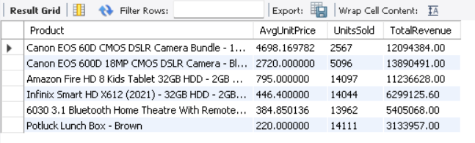

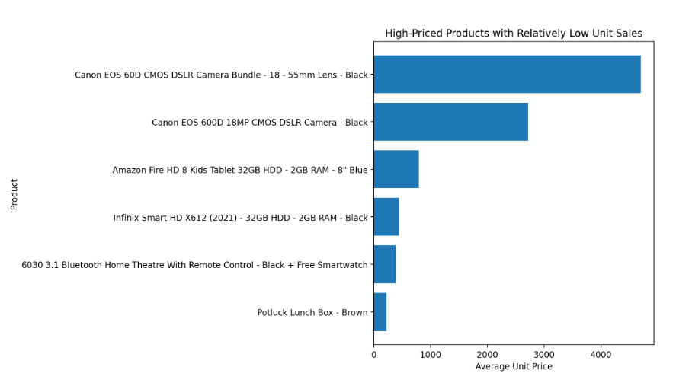

Description:
This analysis identifies expensive products that sell relatively fewer units. Such products may have good revenue potential but may require additional marketing, better product positioning, promotions, or customer education to increase their sales volume.
The analysis focuses on sales quantity, rather than only revenue, because a high-priced product can generate substantial revenue even with relatively few units sold.

Insights
- Canon EOS 60D DSLR Bundle is the clearest high-price/low-volume candidate.
- Canon EOS 600D DSLR is another important candidate.
- These products are not necessarily poor performers in terms of revenue; their issue is low unit volume relative to their high prices.
- High-priced products can generate strong revenue even when fewer units are sold.
- Therefore, units sold should be considered alongside revenue when deciding marketing priorities.

Recommendations:
    - Prioritize Canon EOS 60D and Canon EOS 600D for additional marketing because they combine very high prices with relatively low unit sales.
    - Do not reduce prices immediately. First test bundles, targeted advertising, product demonstrations, and customer-segment-specific promotions.
    - Use a Power BI scatter chart to continuously monitor the relationship between price and sales volume.
    - Track Units Sold, Revenue, Average Unit Price, Rating, and Return Rate together before deciding whether a product genuinely needs intervention.
    - If marketing campaigns increase units sold without significantly reducing profitability, expand the campaign.

Question:7
Assess which products should have discounts. How can targeted incentives drive sales and customer loyalty for specific products?

Solution:

Approach
- Group the orders by Product.
- Calculate average UnitPrice.
- Calculate total OrderQuantity.
- Calculate total SalePrice.
- Identify high-priced products.
- Compare their sales volume.
- Select products with high prices and relatively low unit sales.
- Apply targeted incentives rather than blanket discounts.

DAX Measures

Total Revenue
Total Revenue = SUM(Orders[SalePrice])

Units Sold
Units Sold = SUM(Orders[OrderQuantity])

Average Unit Price
Average Unit Price =AVERAGE(Orders[UnitPrice])

Discount Amount
If you want to simulate a 10% discount in Power BI:
Discounted Revenue = [Total Revenue] * 0.90

SQL Query

SELECT
Product,
AVG(UnitPrice) AS AvgUnitPrice,
SUM(OrderQuantity) AS UnitsSold,
SUM(SalePrice) AS TotalRevenue
FROM Orders
GROUP BY Product
HAVING AVG(UnitPrice) >= 140.25
AND SUM(OrderQuantity) <= 14183
ORDER BY
AvgUnitPrice DESC,
UnitsSold ASC;

Charts & Tables:
- Table / Chart Name:
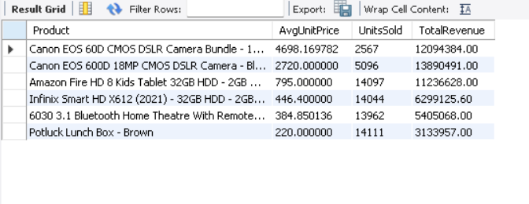

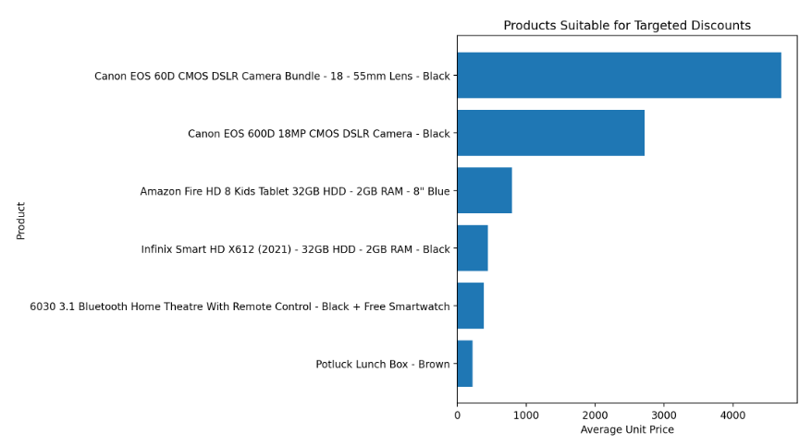

Description:
Discounts should not be given to every product equally. Instead, the company should identify products where a price incentive could potentially increase demand.
High-priced products with relatively low unit sales are suitable candidates because customers may need an additional incentive to complete the purchase.

Insights:
- The Canon EOS 60D DSLR Bundle is the strongest discount candidate because it combines the highest average price with the lowest unit sales among the identified candidates.
- The Canon EOS 600D DSLR is the second-highest priority.
- The Amazon Fire HD 8 and Infinix Smart HD X612 are medium-priority candidates.
- The analysis does not suggest discounting all products.
- Targeted incentives should focus on products where additional demand could potentially justify the reduced price.

Recommendations:
- Start with Canon EOS 60D and Canon EOS 600D and test a controlled discount campaign.
- Use smaller discounts first, such as 5–10%, instead of immediately offering large discounts.
- Prefer bundles over deep price reductions for expensive electronics.
- Give personalized coupons to customers who have shown interest in these products.
- Use loyalty discounts to encourage repeat purchases.
- Monitor the campaign using:
- Units Sold
- Revenue
- Discounted Revenue
- Order Count
- Customer Repeat Rate
- Compare before vs. after promotion performance to determine whether the incentive actually increases sales.

Question:8
Come up with a loyalty program to benefit the company’s customers. From the available lot of customers come up with strategies to bucket them and provide benefits under different loyalty programs.

Solution:

Increasing the price of cuisines does not strongly guarantee better customer ratings.
The correlation between Average Cost for Two and Aggregate Rating is weak, which means higher prices do not directly lead to higher feedback scores.
Therefore, simply keeping cuisine rates higher may not significantly improve customer ratings.

Approach:
Customer-level revenue was calculated as:
Total Revenue = SUM(SalePrice)
Then customers were divided using data-driven revenue thresholds:
Tier | Revenue Condition
Platinum | ≥ ₹4,707
Gold | ₹1,156 – ₹4,706
Silver | ₹400 – ₹1,155
Bronze | < ₹400
These thresholds are derived from the actual customer revenue distribution rather than arbitrary customer values.

DAX Measures

Total Revenue
Total Revenue =SUM(Orders[SalePrice])

Total Orders
Total Orders = DISTINCTCOUNT(Orders[OrderID])

Total Units Purchased
Total Units Purchased = SUM(Orders[OrderQuantity])

Customer Revenue
Customer Revenue =CALCULATE([Total Revenue],ALLEXCEPT(
Orders, Orders[CustomerID] ))

Charts & Tables:
- Table / Chart Name:
Revenue Contribution by Loyalty Tier

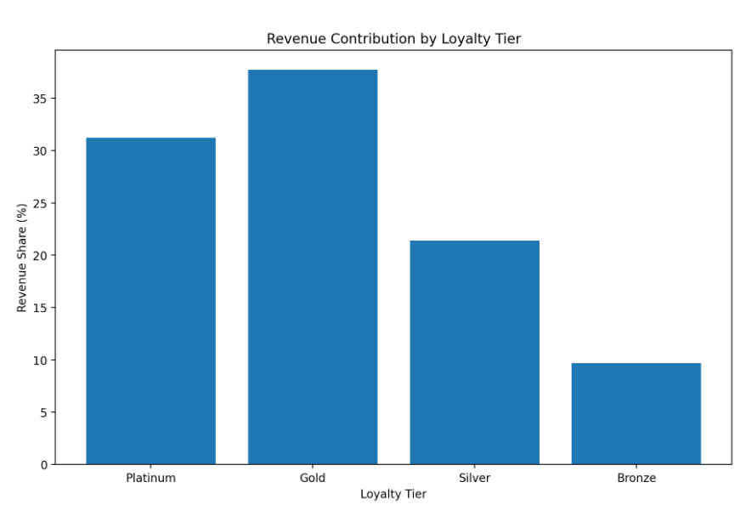

Description:
The proposed loyalty program divides customers into four tiers:
- Platinum – highest-value customers
- Gold – high-value customers
- Silver – medium-value customers
- Bronze – entry-level customers
The objective is to give stronger benefits to customers who contribute more revenue while providing lower-cost incentives to Bronze customers to encourage them to move to higher tiers.

Insights:

1. Gold customers are the most valuable segment by total revenue
Gold contributes 37.71% of total revenue, making it the most important group for retention and upselling.

2. Platinum customers are highly valuable
Although there are only 5,755 Platinum customers, they contribute 31.23% of revenue.

3. Bronze is the largest customer group
There are 56,482 Bronze customers, but they contribute only 9.67% of revenue.
This creates an opportunity to increase their spending through low-cost promotional incentives.

4. Silver is the key upgrade segment
Silver customers already contribute 21.38% of revenue. Encouraging them to reach Gold could produce significant additional revenue.

Recommendations:
- Prioritize Gold and Platinum customers, because together they generate 68.94% of revenue.
- Create a Gold-to-Platinum upgrade campaign using additional rewards when customers cross the Platinum spending threshold.
- Target Silver customers with personalized offers to move them toward Gold.
- Use low-cost incentives for Bronze customers, such as coupons, free shipping, and bundle offers rather than expensive rewards.
- Avoid giving the same discount to every customer. Higher-value customers should receive higher-value benefits.
- Track tier movement in Power BI so the company can see how many customers move from Bronze → Silver → Gold → Platinum.
- Add repeat-purchase history in future data collection. Since the current dataset does not provide enough repeated orders per customer to measure genuine loyalty/frequency, future analysis should include multiple purchase periods per CustomerID.

Question:9
Using the DAX functions Calculate and a row iteration DAX function calculate the total sales for the Product Category “Fashion” and delivery type “Shipped from Abroad”. What are the other types of DAX functions you have used in the project?

Solution:

The purpose of this analysis is to calculate the total sales generated by Fashion products that were shipped from abroad.
The analysis also demonstrates the use of:
- CALCULATE() for applying filters.
- SUMX() as a row-iteration function.
- Other DAX functions used throughout the Power BI project.
Your dataset contains the required fields ProductCategory, DeliveryType, OrderQuantity, and SalePrice.

Approach
The calculation was performed using the following steps:
- Start with the Orders table.
- Filter ProductCategory to Fashion.
- Filter DeliveryType to Shipped from Abroad.
- Use SUMX() to iterate through the filtered rows.
- Add the SalePrice values for the qualifying rows.
- Return the final total sales amount.

DAX Query:
Fashion Abroad Sales =
CALCULATE(
SUMX(
Orders,
Orders[SalePrice]
),
Orders[ProductCategory] = "Fashion",
Orders[DeliveryType] = "Shipped from Abroad"
)

Other DAX Functions Used in the Project
Based on the calculations and dashboard work in this project, the important DAX functions can be grouped as follows:
DAX Function | Type | Purpose
SUM | Aggregation | Calculates total sales/revenue
AVERAGE | Aggregation | Calculates average price/rating
COUNT | Aggregation | Counts values
COUNTROWS | Aggregation | Counts rows
DISTINCTCOUNT | Aggregation | Counts unique customers/orders
MIN / MAX | Aggregation | Finds minimum/maximum values
SUMX | Iterator | Performs row-by-row calculations
AVERAGEX | Iterator | Calculates average after row iteration
CALCULATE | Filter/Context | Changes filter context
FILTER | Filter | Creates a filtered table
ALL | Filter | Removes filters
ALLEXCEPT | Filter | Removes filters except specified columns
DIVIDE | Mathematical | Safely performs division
IF | Logical | Creates conditional calculations
SWITCH | Logical | Handles multiple conditions/categories
VALUES | Filter/Table | Returns distinct values
MINX / MAXX | Iterator | Finds minimum/maximum after row iteration

Examples from Your Project

1. Total Revenue — SUM
Total Revenue =SUM(Orders[SalePrice])

2. Unique Customers — DISTINCTCOUNT
Unique Customers = DISTINCTCOUNT(Orders[CustomerID])

3. Average Rating — AVERAGE
Average Rating = AVERAGE(Orders[Rating])

4. Revenue Share — DIVIDE + CALCULATE + ALL
Revenue Share % =
DIVIDE(
[Total Revenue],
CALCULATE(
[Total Revenue],
ALL(Orders[Location])
)
)

5. Conditional Classification — SWITCH + TRUE
Loyalty Tier =
SWITCH(
TRUE(),
[Customer Revenue] >= 4707, "Platinum",
[Customer Revenue] >= 1156, "Gold",
[Customer Revenue] >= 400, "Silver",
"Bronze"
)

6. Row Iteration — SUMX
Total Sales =
SUMX(
Orders,
Orders[SalePrice]
)

Charts & Tables:
- Table / Chart Name:
Not Applicable

Description:
This measure calculates the total sales generated by Fashion products that were delivered through the "Shipped from Abroad" delivery type.
The CALCULATE function applies the required business filters, while SUMX performs row-by-row aggregation of SalePrice.

Insights:
- Fashion products shipped from abroad generated ₹4,135,434 in sales.
- The filtered data contains 11,134 records.
- These records represent 61,252 units.
- CALCULATE() is useful when the analysis requires specific business conditions.
- SUMX() demonstrates how DAX can perform calculations at the individual-row level before aggregating the result.
- The result can be compared with other delivery types or product categories to understand their contribution to sales.

Recommendations:
- Monitor Fashion + Shipped from Abroad sales separately to understand the contribution of this delivery channel.
- Compare this result with Express and Standard Delivery to determine which delivery method generates stronger Fashion sales.
- Use Power BI slicers to allow management to analyze the result by Location, Zone, Product, and SubCategory.
- If Shipped from Abroad generates strong sales, the company can consider promoting selected Fashion products through this delivery channel.
- Combine this analysis with rating and return data before increasing investment, because high sales alone do not necessarily mean strong customer satisfaction.
- Use the CALCULATE() + SUMX() pattern for similar business questions where specific filters and row-level calculations are required.

Question:10
Wait Times Correlated with Demographics and Care: Explore how average wait times vary across different product categories to optimize scheduling and staffing.

Solution:

the available data contains OrderDate and DeliveryDate, so wait time is interpreted as the number of days between order placement and delivery. The dataset also contains CustomerID, Location, and Zone, but it does not contain demographic fields such as age, gender, or income, nor does it contain a "care" variable.

Approach
- Convert OrderDate and DeliveryDate into date format.
- Calculate the waiting/delivery time for every order.
- Calculate the average wait time for each ProductCategory.
- Compare the categories.
- Identify categories with relatively higher waiting times.
- Use the results to support delivery scheduling and operational resource allocation.

DAX Measures:

1. Wait Time in Days

Wait Time Days =
DATEDIFF(
Orders[OrderDate],
Orders[DeliveryDate],
DAY
)

2. Average Wait Time

Average Wait Time =
AVERAGE(Orders[Wait Time Days])

Charts & Tables:
- Table / Chart Name:
Average Wait Time by Product Category
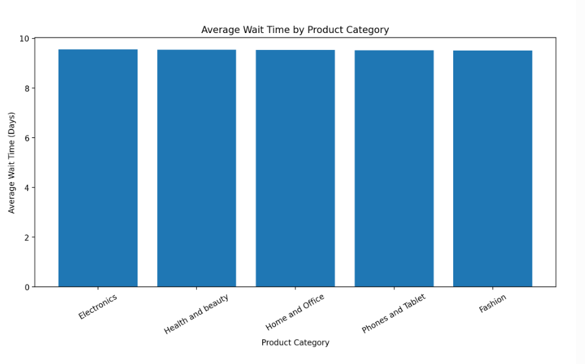

Description
The analysis indicates that average delivery/wait times are very similar across all product categories.
Electronics has the highest average wait time at approximately 9.55 days, while Fashion has the lowest at approximately 9.51 days.
Therefore, there is no strong category-level difference in average wait time in the available data.
This means that staffing decisions should not be based only on product category. Other factors such as delivery type, location, zone, and order volume should also be investigated.

Insights
Insight 1 – Electronics has the highest wait time
Electronics has an average wait of approximately 9.55 days, making it the category with the highest average delivery time.
Insight 2 – Fashion has the lowest wait time
Fashion has an average wait of approximately 9.51 days.
Insight 3 – Category differences are minimal
The difference between Electronics and Fashion is only about 0.05 day.
Therefore, there is no evidence of a major waiting-time problem specific to one product category.
Insight 4 – Order volume is important
Health and beauty has approximately 35,952 orders, substantially more than Electronics at 10,273 orders.
Even though Health and beauty does not have the highest average wait, its much larger order volume may require more operational capacity.

Recommendations
1. Do not increase staffing based only on category
Because all categories have average wait times around 9.5 days, category alone does not explain a significant difference.
2. Focus on high-volume categories
Health and beauty has the highest number of orders. Even with an average wait similar to other categories, its large workload may require more operational capacity.
3. Analyze delivery type
Compare:
- Express
- Standard Delivery
- Shipped from Abroad
This could reveal a stronger driver of waiting time than product category.
4. Analyze location and zone
Use Location and Zone to identify areas with longer delivery times and allocate delivery resources accordingly.
5. Monitor Electronics
Electronics has the highest average wait, so it should be monitored for potential delays, although the difference from other categories is currently very small.
6. Improve future data collection
If demographic analysis is required in the future, add appropriate customer attributes such as age group, gender, or customer segment to the customer table.

Question:11
Explore if there is any relationship between the Delivery type and waiting time between ordering and receiving an item.

Solution:

The objective is to determine whether the type of delivery service affects the waiting time between placing an order and receiving the item.
The dataset contains OrderDate, DeliveryDate, and DeliveryType, so waiting time can be calculated directly from the available data. The three delivery types in the data are Express, Standard Delivery, and Shipped from Abroad.
.

Approach
The analysis was performed in the following steps:
- Calculate the number of days between OrderDate and DeliveryDate.
- Group the orders by DeliveryType.
- Calculate the average waiting time for each delivery type.
- Compare the delivery types.
- Use the result to determine whether delivery type has a relationship with waiting time.

Calculation
Waiting Time = Delivery Date − Order Date

DAX Solution:

Step 1. Calculate Waiting Time
Create a calculated column:

Wait Time Days = DATEDIFF(Orders[OrderDate],
Orders[DeliveryDate],
DAY
)

Step 2. Calculate Average Waiting Time
Average Wait Time = AVERAGE(Orders[Wait Time Days])

Step 3 – Number of Orders

Total Orders = DISTINCTCOUNT(Orders[OrderID])

Charts & Tables:
- Table / Chart Name:
Average Waiting Time by Delivery Type

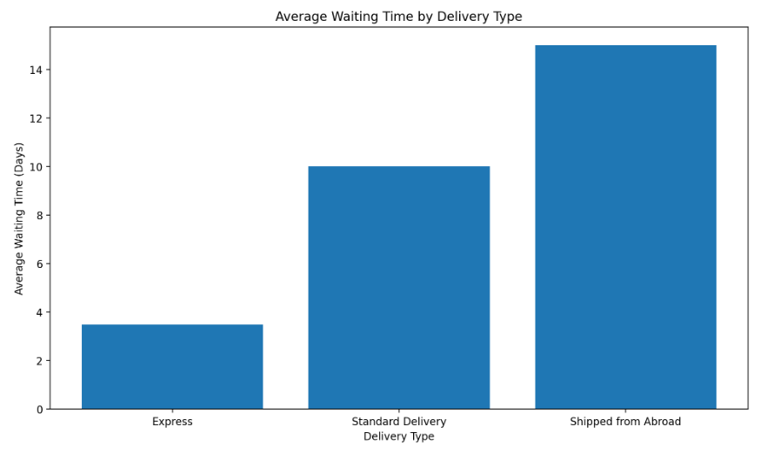
Description
There is a clear relationship between Delivery Type and waiting time.
- Express has the shortest waiting time at approximately 3.49 days.
- Standard Delivery takes approximately 10 days.
- Shipped from Abroad takes approximately 15 days.
Therefore, customers choosing Express delivery receive their orders much faster, while international/abroad shipping has the longest waiting period.

Insight: -

Insight 1 – Express is significantly faster

Express delivery averages only 3.49 days, making it the fastest option.

Insight 2 – Standard Delivery is substantially slower

Standard Delivery averages approximately 10 days, around 6.5 days longer than Express.

Insight 3 – Shipped from Abroad has the longest wait

Orders shipped from abroad take approximately 15 days, about 11.5 days longer than Express.

Insight 4 – Delivery type is a strong operational driver

The difference between delivery methods is much larger than the small differences previously observed between product categories.

Therefore, delivery type appears to be a more important factor in waiting time than product category.

Insight 5 – Order volumes are similar

Each delivery type has roughly 37,000–38,000 orders, so the difference in waiting time is not simply because one delivery type has an extremely small sample.

Recommendations:
1. Promote Express for time-sensitive customers
Customers who require faster delivery should be encouraged to choose Express delivery.
2. Improve Standard Delivery
Since Standard Delivery takes approximately 10 days, the company should identify opportunities to reduce processing and transportation time.
3. Set realistic expectations for international shipping
Because Shipped from Abroad averages approximately 15 days, the expected delivery date should be clearly communicated to customers.
4. Optimize international logistics
The company should investigate:
- Customs delays
- International transportation
- Warehouse processing
- Supplier location
- Cross-border logistics
to determine where the additional waiting time occurs.
5. Use delivery type in staffing and scheduling
Staffing and logistics planning should consider delivery type separately. Express orders require faster processing, while Shipped from Abroad requires more long-term logistics planning.
6. Monitor customer satisfaction
Compare waiting time with Rating and Status/Reason to determine whether longer delivery times are associated with lower customer satisfaction or more returns. These fields are available in the dataset.

Question:12
Is there any relationship between shipping charges and product type?

Solution:

The objective is to determine whether shipping charges vary significantly across different product categories.
The analysis uses the available ShippingFee and ProductCategory fields from the Orders data. The source also contains OrderID, OrderQuantity, SalePrice, and other order-level fields.

Approach
The analysis follows these steps:
- Group orders by ProductCategory.
- Calculate the average shipping charge for each category.
- Calculate the total shipping charges for each category.
- Compare the average charges across categories.
- Determine whether product category has a meaningful relationship with shipping charges.

Calculation
Average Shipping Charge = Total Shipping Fee / Number of Orders

DAX Solution:

Total Shipping Fee

Total Shipping Fee = SUM(Orders[ShippingFee])

Average Shipping Fee
Average Shipping Fee = AVERAGE(Orders[ShippingFee])

Charts & Tables:
- Table / Chart Name:
Average Shipping Charge by Product Category
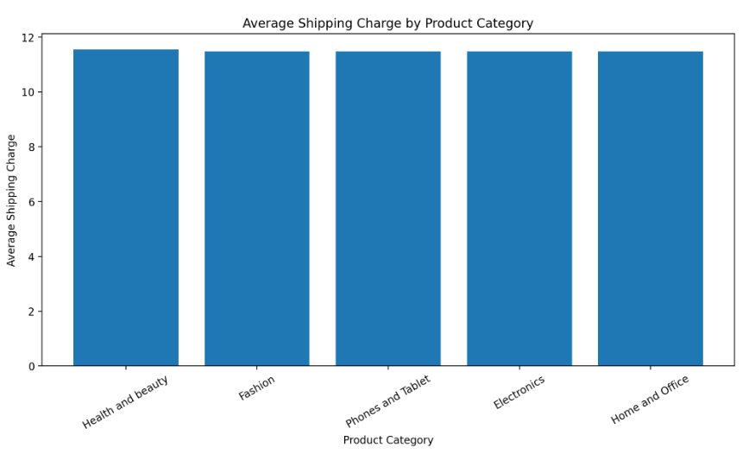
Description
There is a small difference in average shipping charges across product categories, but the difference is not large.
- Health and beauty has the highest average shipping fee: 11.55.
- Home and Office has the lowest: 11.47.
- The difference between the highest and lowest average is only about 0.07.

Insight: -
Insight 1 – Health and beauty has the highest average charge
Health and beauty has an average shipping fee of approximately 11.55.

Insight 2 – Home and Office has the lowest
Home and Office has an average shipping fee of approximately 11.47.

Insight 3 – Difference is very small
The difference between the highest and lowest category is only around 0.07.
This suggests that product category itself is not a major driver of average shipping charges in the available data.

Insight 4 – Total shipping cost is influenced by order volume
Health and beauty has the highest total shipping fee (415,079) because it also has a large number of orders (35,952).

Recommendations:
- Do not introduce category-specific shipping charges solely based on these results, because average shipping fees are almost identical across categories.
- Investigate other factors that may have a stronger effect on shipping charges, such as:
- DeliveryType
- Location
- Zone
- OrderQuantity
- Product weight/dimensions, if available.
- Since Health and beauty has the highest total shipping cost, investigate whether its high order volume creates opportunities for bulk-shipping or logistics optimization.
- Use free-shipping thresholds to encourage customers to increase their order value rather than changing shipping charges by product category.
- Analyze shipping charges by DeliveryType × ProductCategory to identify whether the relationship becomes clearer when delivery method is considered.

Question:13
Come up with strategies to decrease the low rating orders after analyzing different factors like waiting time, shipping type, unit price, etc.

Solution:

The objective is to identify the major factors associated with low customer ratings and recommend practical strategies to reduce them.
For this analysis, ratings of 1 and 2 are treated as low ratings. The available Orders data contains Rating, OrderDate, DeliveryDate, DeliveryType, UnitPrice, ShippingFee, ProductCategory, Status, and Reason, allowing these factors to be examined.

Approach
The analysis was performed in the following steps:
- Define ratings 1–2 as low ratings.
- Calculate waiting time:
Waiting Time = DeliveryDate − OrderDate
- Compare low-rating rates across:
  - Waiting time
  - Delivery type
  - Unit price
  - Shipping fee
  - Product category
- Analyze the Reason field for low-rated orders.
- Identify the strongest operational problems.
- Recommend targeted actions to reduce low ratings.

DAX Solution:

Low Rating Orders

Low Rating Orders =
CALCULATE(
DISTINCTCOUNT(Orders[OrderID]),
Orders[Rating] <= 2
)

Total Orders
Total Orders =
DISTINCTCOUNT(Orders[OrderID])

Low Rating %

Low Rating % =
DIVIDE(
[Low Rating Orders],
[Total Orders],
0
)

Waiting Time

Wait Time Days =
DATEDIFF(
Orders[OrderDate],
Orders[DeliveryDate],
DAY
)

Average Waiting Time

Average Wait Time =
AVERAGE(Orders[Wait Time Days])

Charts & Tables:
- Table / Chart Name:
Low-Rating Rate by Delivery Type 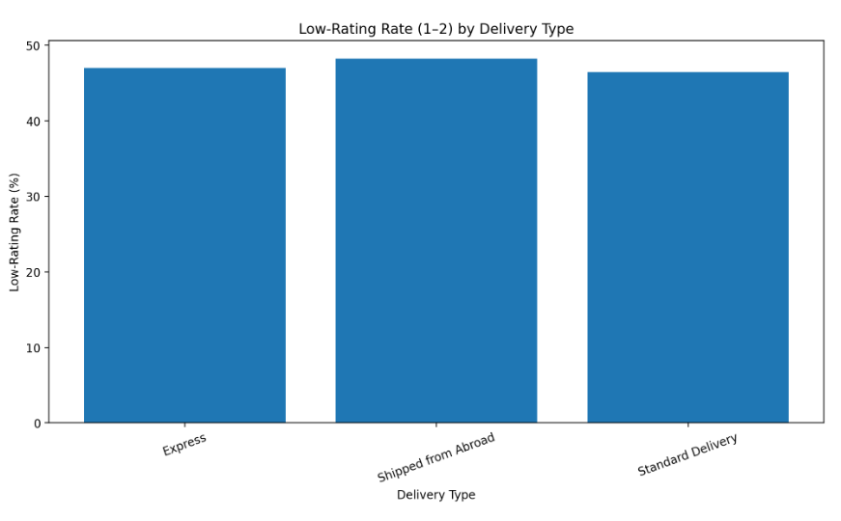
Description
The dataset contains Description mismatch and Not fitting expectation reasons.
Improve:
- Product dimensions
- Product specifications
- Images
- Material information
- Size information
- Compatibility details
This should reduce the gap between customer expectations and the actual product.

Insight: -

Insight 1

Almost 47.22% of orders have a rating of 1 or 2.

Insight 2
Longer delivery times show a slightly higher low-rating rate, with 14–20 day orders reaching 48.34%.

Insight 3
Shipped from Abroad has the highest low-rating rate among delivery types at 48.23% and also has the longest average waiting time.

Insight 4
Unit price and shipping fee show only small differences in low-rating rates.

Insight 5
Product category also has relatively small differences.

Insight 6 — Most Important
The recorded reasons point more directly toward quality defects, missing parts, wrong items, expectation mismatches, and description mismatches.

Recommendations:
1. Improve Product Quality Control
Because Quality-Defective item is the largest recorded reason, introduce stronger quality checks before dispatch.
Strategy:
Supplier Quality Check → Warehouse Inspection → Dispatch
2. Improve Order-Picking Accuracy
Wrong items and missing parts are major recorded problems.
Use:
- Barcode scanning
- Order verification
- Packing checklist
- Final dispatch confirmation
This can reduce fulfillment-related dissatisfaction.
3. Improve Product Descriptions
The dataset contains Description mismatch and Not fitting expectation reasons.
Improve:
- Product dimensions
- Product specifications
- Images
- Material information
- Size information
- Compatibility details
This should reduce the gap between customer expectations and the actual product.
4. Improve International Delivery
Shipped from Abroad has the longest average wait and the highest low-rating rate among delivery types.
The company should:
- Improve delivery-time estimates.
- Track international shipments.
- Communicate delays proactively.
- Provide realistic expected delivery dates.
5. Monitor Long-Wait Orders
Orders approaching 14+ days should be flagged for monitoring because the low-rating rate is higher in this group.

Create a Power BI alert/flag such as:
Wait Time Risk =
IF(
Orders[Wait Time Days] >= 14,
"High Risk",
"Normal"
)

6. Do Not Use Blanket Discounts as the Main Solution
The analysis shows that unit price and shipping fee have only small differences in low-rating rates.
Therefore, reducing prices or shipping charges for everyone may reduce revenue without solving the main customer-experience problems.

Question:14
Using the time intelligence DAX function, create a table to compare each month’s sales with the previous year’s same month’s total sales. So there will be four columns in the output year, month, total sales, previous_years_sales.

Solution:

Approach
The analysis follows these steps:
- Create a proper Calendar/Date table.
- Create a relationship between Calendar[Date] and Orders[OrderDate].
- Create a Total Sales measure.
- Use SAMEPERIODLASTYEAR() to retrieve sales from the same period in the previous year.
- Put Year, Month, Total Sales, and Previous_Years_Sales into a Power BI table visual.

DAX Solution:

Step 1 — Create Calendar Table

Calendar =
ADDCOLUMNS(
CALENDAR(
MIN(Orders[OrderDate]),
MAX(Orders[OrderDate])
),
"Year", YEAR([Date]),
"Month Number", MONTH([Date]),
"Month", FORMAT([Date], "MMMM")
)

Step 2 — Total Sales Measure
Total Sales = SUM(Orders[SalePrice])

Step 3 — Previous Year's Sales

Previous Years Sales =
CALCULATE(
[Total Sales],
SAMEPERIODLASTYEAR(Calendar[Date])
)

Waiting Time

Wait Time Days =
DATEDIFF(
Orders[OrderDate],
Orders[DeliveryDate],
DAY
)

Average Waiting Time

Average Wait Time =
AVERAGE(Orders[Wait Time Days])

Charts & Tables:
- Table / Chart Name:
Not Applicable

Description
This analysis uses Time Intelligence to compare sales performance month by month against the corresponding month of the previous year.
The Total Sales measure calculates the current month's sales using SUM(Orders[SalePrice]).
The Previous Years Sales measure uses:
SAMEPERIODLASTYEAR(Calendar[Date])
to move the current month one year backward and retrieve the corresponding previous-year sales.
This allows management to identify whether monthly sales are improving or declining compared with the same month in the previous year.

Insight: -
If previous-year data is available, this table can identify:
- Months with higher sales than the previous year.
- Months with declining sales.
- Seasonal patterns.
- Strong and weak sales periods.
- Monthly year-over-year performance.
However, with the currently described May–June 2020 dataset, a genuine previous-year comparison cannot be calculated because 2019 data is not available.

Recommendations:
- Maintain a complete Date table for all dates required for time-intelligence calculations.
- If year-over-year analysis is required, include at least two years of sales data.
- Use SAMEPERIODLASTYEAR() rather than manually subtracting 365 days because it is designed for standard time-intelligence analysis.
- Add a YoY Sales Growth % measure once previous-year data is available:

YoY Growth % =
DIVIDE(
[Total Sales] - [Previous Years Sales],
[Previous Years Sales],
0
)
- Use the monthly comparison in the dashboard to identify periods requiring additional promotions or sales strategies.

Question:15
What do you understand by PowerBI gateway? What are its use cases?

Solution:

The objective is to understand the purpose of a Power BI Gateway and how it helps Power BI access data that is stored outside the Power BI Service, especially when the data source is inside an organization's local/on-premises environment.

A Power BI Gateway is a software/service that acts as a bridge between Power BI Service and data sources that Power BI cannot directly access from the cloud.
Simple explanation:
On-Premises / Local Data
↓
Power BI Gateway
↓
Power BI Service
↓
Power BI Dashboard / Report
For example, suppose a company stores its sales data in a local SQL Server inside its office.
Power BI Service is cloud-based, so it needs a secure way to communicate with that local database.
The Power BI Gateway provides that connection.

Approach
To use a gateway:
- Install the Power BI Gateway on a machine that can access the required data source.
- Configure the data source/connection.
- Sign in and register the gateway with the Power BI Service.
- Connect the Power BI dataset to the gateway.
- Configure scheduled refresh if required.
- Power BI Service uses the gateway to retrieve updated data.

Main Use Cases

Use Case 1 — Scheduled Data Refresh
This is one of the most common uses.
Suppose the company has an on-premises SQL database that receives new orders every day.
SQL Server
↓
Gateway
↓
Power BI Dataset
↓
Dashboard
The gateway allows Power BI to refresh the dataset automatically according to the configured schedule.

Use Case 2 — Accessing On-Premises Data
Organizations may have data stored in:
- SQL Server
- Excel files on a local/network location
- Other supported on-premises data sources
The gateway allows Power BI Service to communicate with these sources.

Use Case 3 — Keeping Reports Updated
When the underlying data changes, the gateway can help Power BI retrieve the latest data during refresh.
For example:
New Sales
↓
Company Database Updated
↓
Gateway
↓
Power BI Dataset Refresh
↓
Updated Dashboard

Use Case 4 — Live / DirectQuery Scenarios
A gateway can also be used when Power BI needs to query an on-premises data source rather than importing all the data into Power BI.
This is useful when an organization wants reports to work with data that remains in its existing database environment.

Use Case 5 — Centralized Data Connectivity
Organizations can configure a gateway so that multiple Power BI datasets and reports can use approved connections to the same on-premises data sources.
This makes administration easier than creating completely separate connections for every report.

Types of Power BI Gateway
There are two important gateway modes:
1. Standard Mode
Used mainly in organizational environments.
It supports multiple users and multiple data sources and is suitable for enterprise-level Power BI deployments.
2. Personal Mode
Primarily intended for individual users and personal Power BI scenarios.
It is more limited than the standard/enterprise gateway approach.

Charts & Tables:
- Table / Chart Name:
No Applicated

Insight: -

It is especially useful when:

Data is stored inside the organization's network.

Reports need scheduled refresh.

Manual uploading of data is not desirable.

Power BI needs to query an on-premises source.

It is not simply a tool for creating dashboards. Its main purpose is data connectivity between Power BI Service and supported data sources that require a gateway.

Recommendations:
- Use a standard gateway for organizational/enterprise reporting.
- Configure scheduled refresh when the underlying data changes regularly.
- Keep the gateway machine available and connected to the required data source.
- Use appropriate credentials and permissions for each data source.
- Monitor gateway health and refresh failures.
- Use gateway connectivity when the organization's data must remain on-premises rather than being manually uploaded to the Power BI Service.

Question:16
How would you approach this problem, if the objective and subjective questions weren't given?

Solution:
If no predefined objective or subjective questions were provided, I would not start by randomly creating charts or SQL queries.
I would first understand the available data, perform Exploratory Data Analysis (EDA), identify important business metrics, find patterns and problems, and then convert those findings into meaningful business questions.
The available Orders data contains fields such as OrderDate, DeliveryDate, CustomerID, Location, Zone, DeliveryType, ProductCategory, Product, UnitPrice, ShippingFee, OrderQuantity, SalePrice, Status, Reason, and Rating.

Approach
Step 1 — Understand the Dataset
First, I would identify:
- Number of rows and columns
- Data types
- Primary keys
- Important dimensions
- Important measures
- Missing values
- Duplicate records
- Date range
For this project, the main tables/data fields would allow analysis of sales, customers, products, delivery, returns, and customer ratings.
Step 2 — Clean and Validate the Data
I would check:
- Missing values
- Duplicate OrderID
- Incorrect date formats
- Invalid numeric values
- Blank ratings
- Incorrect category names
- Inconsistent delivery types
- Returned orders and their reasons
Only after validating the data would I proceed to analysis.

Step 3 — Perform EDA
I would explore the data from different business perspectives.
Sales Analysis
- Total Sales
- Revenue by month
- Revenue by product category
- Revenue by location
- Top-selling products
Customer Analysis
- Number of customers
- Repeat customers
- Customer purchase frequency
- High-value customers
Product Analysis
- Top products
- Low-selling products
- Product-category performance
- Unit price vs sales
Delivery Analysis
- Average waiting time
- Delivery type comparison
- Location-wise delivery performance
Customer Satisfaction
- Average rating
- Low-rating orders
- Rating by product
- Rating by delivery type
Returns Analysis
- Number of returned orders
- Return rate
- Return reasons
- Product categories with high returns

Define KPIs
After EDA, I would define the most important KPIs.
Area | KPI
Sales | Total Sales
Sales | Average Order Value
Customers | Unique Customers
Customers | Orders per Customer
Products | Total Products
Delivery | Average Wait Time
Customer | Average Rating
Customer | Low Rating %
Returns | Return Rate
Delivery | Orders by Delivery Type
These KPIs would become the foundation of the Power BI dashboard.

Visualization Approach:-
I would then select the visualization based on the business question.
Analysis | Recommended Visual
Sales trend | Line Chart
Revenue by category | Column Chart
Top products | Bar Chart
Location performance | Map / Bar Chart
Delivery type vs wait time | Column Chart
Rating vs waiting time | Scatter Chart
Return reasons | Bar Chart
Customer segmentation | Donut / Bar Chart
Monthly sales comparison | Line Chart
KPI monitoring | Cards

Charts & Tables:
- Table / Chart Name:
Not Applicable

Description
When the business questions are not provided, the analyst's responsibility is to discover what questions the data can answer.
Instead of starting with:
"What chart should I make?"
I would start with:
"What business decisions can this data help the company make?"
This approach makes the analysis data-driven rather than question-driven.

Insight: -
Without predefined questions, EDA can reveal areas such as:
- Products generating high or low sales
- Categories contributing most revenue
- Locations with stronger sales
- Customers with high purchase value
- Delivery types associated with longer waiting times
- Products/categories associated with low ratings
- Major return reasons
- Products that may need marketing or pricing attention
The available dataset explicitly contains the fields needed to investigate these sales, delivery, product, return, and customer-satisfaction areas.

Recommendations:
- Start with data profiling before visualization.
- Clean and validate the dataset before calculating KPIs.
- Use EDA to discover patterns, trends, and anomalies.
- Convert important findings into business questions.
- Select SQL, DAX, or Power BI analysis according to the question.
- Use the appropriate visualization rather than creating charts randomly.
- Finish every important analysis with an insight and actionable recommendation.
- Build the final dashboard around stakeholder decisions, not simply around the available columns.

